DIS-MEX-Mezcala-head-ex Niven

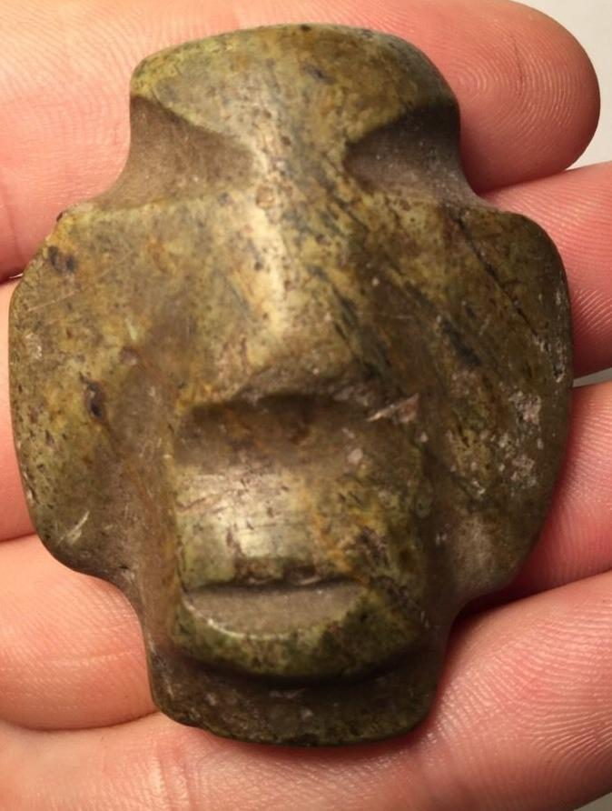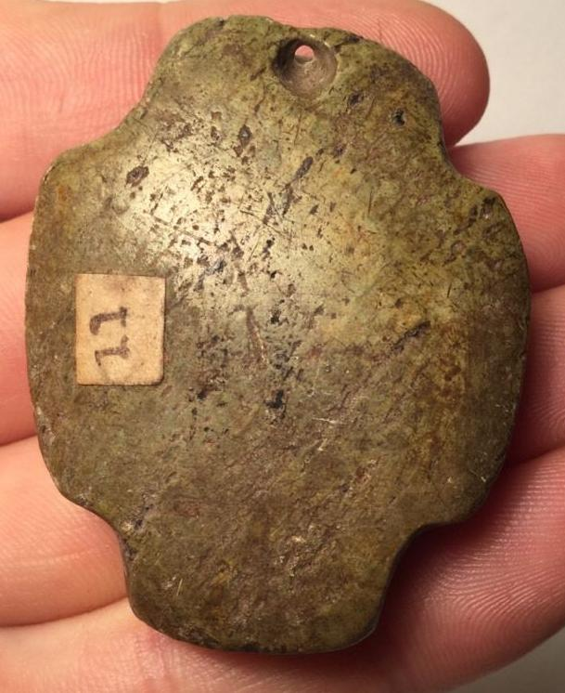

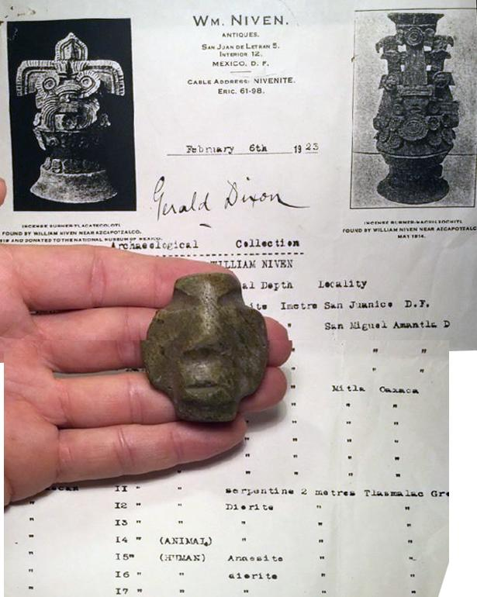

Ok. How many Mezcala have you seen with documented 1920s provenance including the area found? Zero. Found at San Miguel Amantla at a depth of 2 meters.

2" tall includes a copy of paperwork.

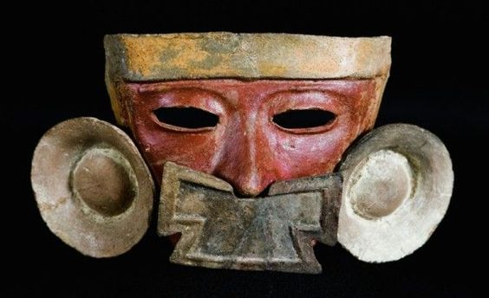

Teotihuacan mask of Azcapotzalco, San Miguel Amantla, Classical period, late Xolalpan phase, Source: Museo Nacional de Antropología Mexico